Design and optimization of patient-specific, pediatric laryngoscopes

###### R. Sims1, M. Boutelle1, J. Inziello1, and F. Lobo Fenoglietto, J. Stubbs1*

1 PD3D Lab, University of Central Florida, Orlando, United States of America

* Corresponding author, email: [jstubbs@ist.ucf.edu](mailto:jstubbs@ist.ucf.edu)

Abstract: Place a brief summary of your work here. Do not use more than 100 words. 3D printing is of outstanding importance in medical engineering and has been growing continuously in recent years. From prostheses and soft implants to matrices for tissue engineering, additive manufacturing has decisive advantages for medicine. The scientific conference AMMM 2019 brings together engineers, scientists and technicians with physicians and entrepreneurs to discuss the latest achievements in 3D printing development for medicine.

# I. Introduction

Originally developed for otolaryngologists to inspect vocal cords, laryngoscopes have undergone continuous modifications since their inception, eventually finding a place in anesthesiology. In 1911, Dr. Chevalier Jackson developed the first laryngoscope that allowed for the insertion of an endotracheal tube (ETT) [1]. In the same year, Dr. Henry Janeway introduced a battery powered, distal light source allowing for optimized viewing conditions [1]. Modern laryngoscopes, such as the Macintosh and Miller, began manufacturing in the early 1940’s. The Macintosh’s continuous curved blade allots more room in the oropharynx for successful passage of the ETT. The Miller’s straight blade design, with curved distal tip, provides an improved view of the glottis [2]. In the last few decades, laryngoscope design changes have focused on addressing challenging airways. Most modern laryngoscopes, such as the McGrath, Glidescope and Airtraq, feature integrated optics and video screens. Additionally, the three brands also feature variable-size, single-use (disposable) blades. Blade sizes are distributed unevenly across adults (3-4 sizes), pediatrics (one size), and neonates (one size). Sizes match a range of ETT sizes (2.5-3.5 for neonate, and 4.0-5.5 for pediatrics) [3].

As the industry moves in the direction of single-use medical devices, there is potential to shift from size groups to patient-specific blades. This is relevant to pediatric and neonatal cases, were size options are limited. Difficulties with intubation represent the main cause of pediatric, anesthesia-related morbidities and mortality [4]. Even in scenarios where difficult intubations are expected, anesthesiologists know to have “all the equipment to hand” [5]. Patient-specific blades would ensure readiness in the case of normal and abnormal airways.

The development of patient specific devices requires the integration of advanced reconstruction, design, and manufacturing technologies. Using SideFX’s Houdini, we have consolidated the design process into a single program (Figure 1).

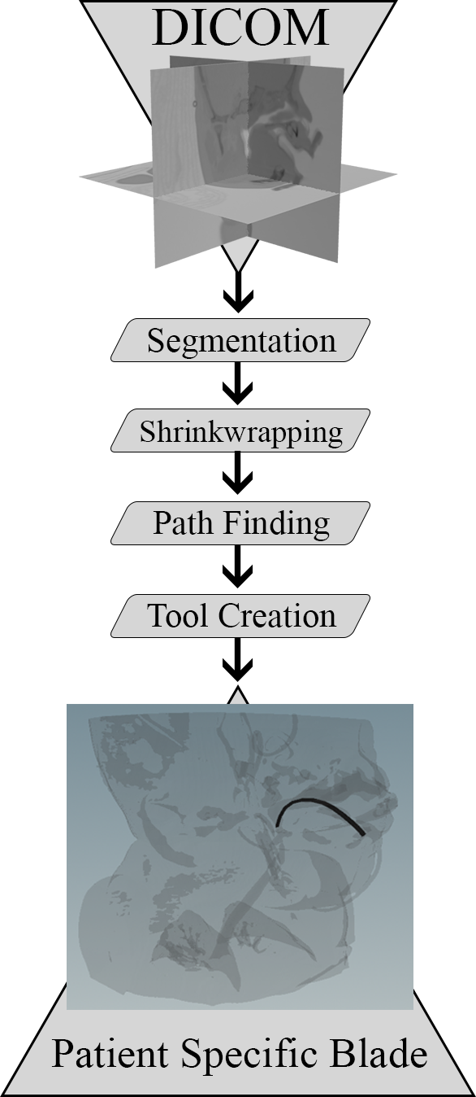

Figure 1: Houdini Program Flowchart

# II. Material and methods

## II.I. Patient data

De-identified or anonymized CT DICOM datasets from three (3) pediatric cases were obtained from Nemours Children’s Hospital (Lake Nona, FL, USA). In addition to age, information retrieved pertained solely to findings that could influence the patient’s airway. The first patient, 18 months old, did not present any lesions or abnormalities affecting the airway. The second patient, 2 months old, presented a lesion deep to the left lobe of thyroid gland and medial to the left common carotid artery. The third patient, also 18 months old, presented a lesion on the right side of the neck. The lesion compromised the patient’s oral cavity, oropharynx, and nasopharynx.

## II.II. Segmentation

Relying on Houdini’s Python 2.x compatibility and Pydicom [ref], our team built custom functions (or nodes in Houdini) to: (1) Import CT DICOM dataset into a voxel (3D pixel) volume, (2) Map the associated Hounsfield data to a [0, 1] density scale, and (3) Pad boundary voxel data to generate a closed geometry.

## II.II. Shrink-wrapping

Through a series of voxel-based erosions and dilations, an enlarged copy of the segmented geometry was used extract the patient’s airway through a Boolean subtraction.

## II.III. Pathfinding

To generate a build path that conforms to the patient’s airway, a space colonization algorithm was implemented [ref]. The mouth was selected as the starting point and no branching was allowed. The point cloud derived from the subtracted airway geometry was used to solve for a path between the mouth and the epiglottis of the patient. For all three patients, the algorithm was forced to stop after the path reached the epiglottis.

## II.IV. Part design and fabrication

The resulting path was used to extrude a cross-section of a laryngoscope blade. The geometry was exported as a surface file (.OBJ) for further editing and fabrication.

# III. Results and discussion

Relevant process parameter value averages and deviations (N=3) were consolidated in Table 1.

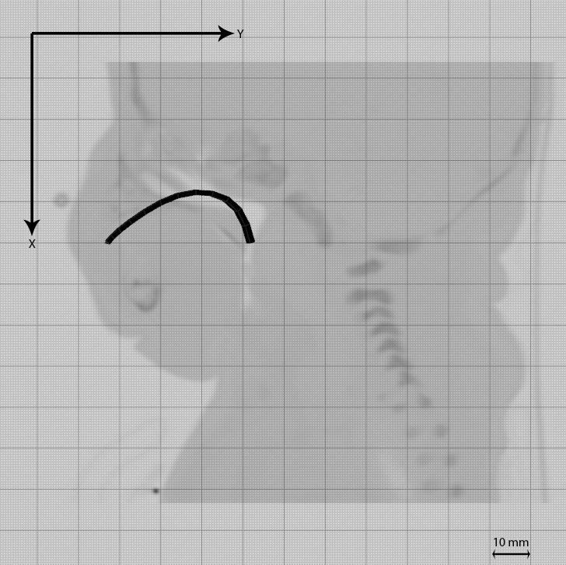Table 1: Values used to achieve airway curvature

|  |  |  |  |
| --- | --- | --- | --- |
| **Parameter** | **Unit** | **Mean** | **SD** |
| Segmentation | Density | 0.2 | 0.0 |
| Voxel Resolution | mm/voxel | 0.56 | 0.33 |
| Erosion Amount | mm | 2.4 | N/A |
| Dilation Amount | mm | 8.0 | N/A |
| Point Separation | mm | 2.33 | 0.94 |
| Frames3 | Number | 8.66 | 1.88 |

Viable, closed geometries were segmented with a fixed threshold value of 0.20. This value represents 20% of the DICOM’s native HU scale. Minimal deviations are expected due to the sharp contrast between air and tissue in HU scale.

Voxel resolution varied in accordance to the patient’s age and size. A resolution of 0.1 mm/voxel was required to preserve the features from the 2 months old patient. In contrast, a resolution of 0.8 mm/voxel was used for the other two patients.

Voxel-based erosions and dilations influence the shrink wrapping process, which ultimately benefits from a smooth and enlarged copy of the segmented geometry. The magnitude of the erosion must be such that surface artifacts disappear. Surface artifacts may consists of feeding and respiratory tubes, leads, catheters, etc. The dilation magnitude must be such that the internal anatomical features are filled. The erosion and dilation parameters reported in Table 1, worked for all three patients.

The pathfinding process relies on a point cloud and a starting position. Point clouds are defined by a reference geometry and a point separation parameter. Much like voxel resolution, point separation was affected by the size of the patient. The airway point cloud of the 2 months old patient featured a 1 mm point separation. While a 3 mm point separation sufficed for the 18 month old patients.

3 depending on the length of the airway, more or less steps in the solving step may be required.

Talk about why going through positive anatomy instead of negative Anatomy?!?!?!?

Pathfinding is still very manual

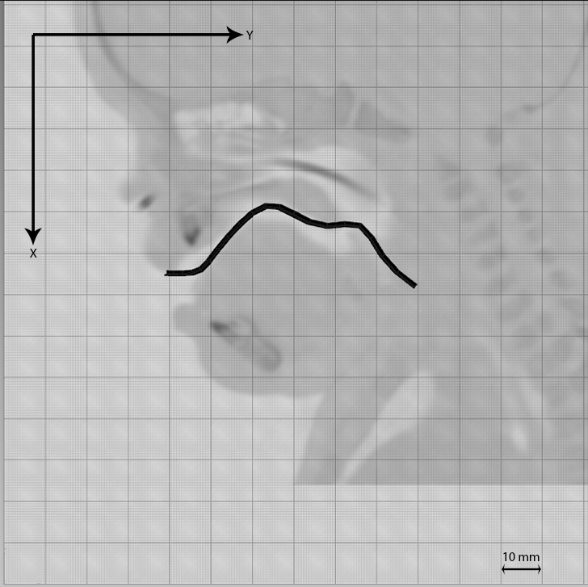

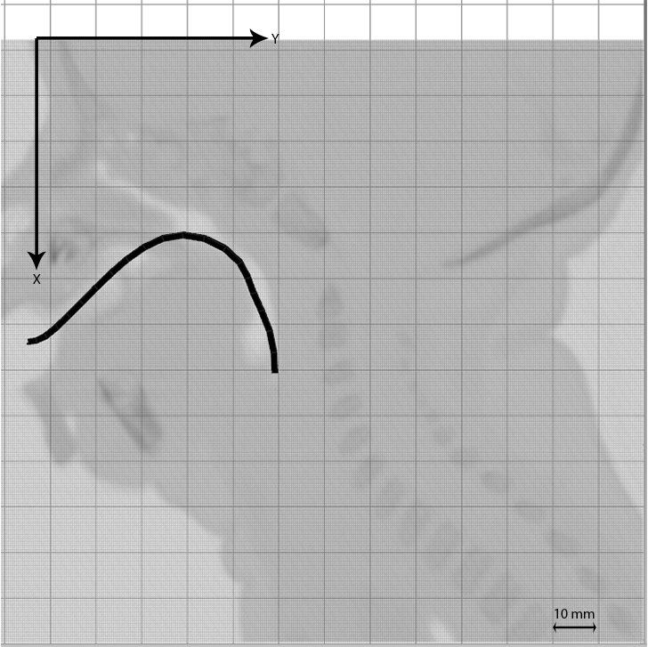

# IV. Conclusions

Although a conclusion may review the main points of the paper, do not replicate the abstract as the conclusion. A conclusion might elaborate on the importance of the work or suggest applications and extensions.

### Acknowledgments

##### The preferred spelling of the word “acknowledgment” in America is without an “e” after the “g”. Avoid the stilted expression, “One of us (R. B. G.) thanks . . .” Instead, try “R. B. G. thanks”.

### Author’s statement

##### Research funding: The author state no funding involved. Conflict of interest: Authors state no conflict of interest. Informed consent: Informed consent has been obtained from all individuals included in this study. Ethical approval: The research related to human use complies with all the relevant national regulations, institutional policies and was performed in accordance with the tenets of the Helsinki Declaration, and has been approved by the authors’ institutional review board or equivalent committee.

#### References

[1] M. Weiss and T. Engelhardt, "Proposal for the management of the unexpected difficult pediatric airway," *Pediatric Anesthesia,* no. 20, pp. 454-464, 2010.

[2] R. W. M. Walker and J. Ellwood, "The Management of difficult intubation in children," *Pediatric Anesthesia,* no. 19, pp. 77-87, 2009.